近江誠の
英語コミュニケーション教育講座教材

中に出てくる英文は、すべて体に染み込ませて、異なる場面で使うシミュレーション練習にもっていくぐらいのつもりで取り組んでみてください。

英語発信力は結局のところは内在化されたインプットの総量に比例するからです。

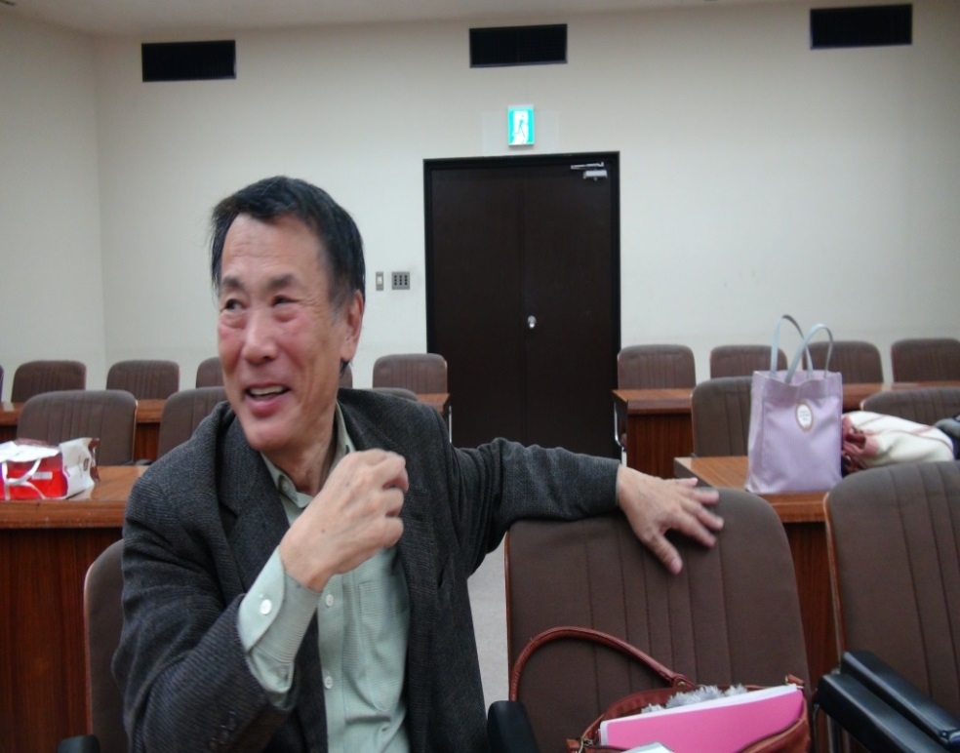

近江誠の英語コミュニケーション教育講座①
－豊かなる出力には豊かなる入力をー

１）目的と訓練（手段）は異なるー
２）豊かなる出力には豊かなる入力

―外国語の学習はその全行程が豊かなる入力を目指しての積み重ねの行程である！ー

３）四つの英語入力―
入力法 １ 聞き流し入力
入力法 ２ 口まね入力
入力法 ３ 多読入力
入力法 ４ (近江メソッド)
コミュニケーション的な視座に立った精読 （＝批判的味読）を土台にした音読とモード転換訓練による豊かな入力

４) 英語のひとりごと
「四つの英語入力法」で蓄積されたことばがコミュニケーションの本番で応用されて出てくるための生活習慣とは…？
近江誠の英語コミュニケーション教育講座②

コミュニケーション的視座に立つ精読（＝批判的味読）とモード転換による言語入力 （＝近江メソッド）
―スピーチ演劇学の、Oral Interpretation (or Interpretive Reading) を使ってー

読む対象としか考えられてこなかったいわゆる文章を、すべて背後に語り手がいる “生きた語り” (パロール)であると捉え、その”雄弁のからくり“を丸ごと体に刷り込む入力である。
詩、エッセー、小説、手紙文、評論文、報道文、レストラン英語メニュー、缶詰のラベル、から、大道芸人トーク、戯曲、劇的モノローグ、独白文、分類をかえれば学校のリーダーから、入試の長文、TOEIC, TOEFL、英検の問題文、すべて ”食材“であり食すことができる。

例文） Your mind, like your body, is a thing of which the powers are developed by effort. That is a principal use, as I see it, of hard work in studies. A good part of what you learn by hard study may not be permanently retained , but your mind is a better and more powerful instrument because you have learnt it. “Knowledge is power,” but still more the faculty of acquiring and using knowledge is power. If you have a trained and powerful mind, you’re bound to have stored it with something, but its value is more in what it can do, what it can grasp and use than in what it contains. (東大、等。『基礎英文問題精講』旺文社）
（ デモ）

―会話（ダイアローグ）ではなくモノローグが基本であるべき
表現同士のわたり具合、話の発展のさせ方が習得できる。雄弁のからくりを線で取り込むことができる。

―どのように刷り込むか？ 非効率的な刷り込み方法
機械的音読、丸暗記、ＣＤをきいて丸暗記には限界がある。
理由：理解が十分に伴っていないから刷り込みに時間がかかる、すぐに忘れる。応用がきかない。

― 効率的な刷り込み方法 理解が伴っての音読⇒だから読みが大切。しかし日本の教育では実は本当の読みは行われてこなかった… これがコミュニケーション的視座に立つ精読（＝批判的味読）の望まれる理由である。
実際にはＰＡＲＴＳ １，２の作業が伴う。

PART 1-その１ コミュニケーション的視座に立った精読（＝批判的味読）

コミュニケーションの七つのポイントを各々単独で捉えるのでなく以下の様に総合的に捉える読みである。

どういう語り手が（POINT 1）、誰に向かって（POINT 2）,いつ(POINT 3)、どこで(POINT 4)、どういう目的を達成さえるために(POINT 5)、どういう内容の話を選択し (POINT 6)、どういう語句や構成、配列み託すことで、互いに単独では持ちえない、どういう意味や機能が付加され、だからどういう音声・身体イメージが浮かび上がってくるか(POINT 7) 。そしてその最終的効果はどうか(Extra 1 POINT)を味わいつつ検討していく精読である [すなわち批評]。
上記の７つのポイントが、どういうつながりを持ちつつ、テキストに内在しているかを発掘する読み。

＊注意！ ５Ｗ１Ｈと、７つのポイントと混同しないこと

これをみると、批判的味読は、上の定義からでもわかるようにテキストの背後にいる語り手が、特定の相手と、時、場所の中で、コミュニケーション目的を定め、それを達成するために、特定の内容を選択し、しかるのちに、その内容に対して特定の語句、展開法[構成]、非言語を選択し、託すところに生ずる機能と共に付加していくものと捉えていることがわかる。この言語観は＜言語パロール観＞。（いっぽう従来のリーディングが、「意味」というものを、語句や、段落やエピソードそのものの中に＜決定済み＞のもの、いわば＜内在している＞と捉える言語観、＜言語ラング観＞に基づく。

● 読み手の立ち位置は基本的に語り手(運転 者目線)のそれ。音読することで全うできる

ただし上の読みが成立するためには読み手での立ち位置をどうとるかとかかわってくる。黙って外から分析する傍観者の立場だけでは達成できない。
まず、語り手（著者あるいはその著者が託した語り手）に自らを重ね併せ、語り手の思考と感情の状態で、声と体を使いながら読む（同化①－運転手目線）。ものによってはPOINT 6の「内容」とかかわる、語り全体が物語的であるとか、差し挟むエピソードが物語的である場合は、その継続的な叙述や描写の展開にそって想像の世界に自己を投入し、登場人物になったつもりで共に行動し同じ心理状態で読む（同化②―乗客目線）つまり書き手と話中の人物〔同じ場合もある〕の二重の同化を行うのである。ただしあくまでも運転者目線に立った「乗客」体験であることを忘れない！
そして、同時にその形式（＝言語・非言語表現）が、語り手のコミュニケーション目的をいかに満たしているかどうかを外から評価、且つ味わい（「異化」―河川敷目線）する。
同化と異化の間の絶えざる往復が必要である。これにより観念的理解と情緒的理解の間を往復作業により理解は弁証法的に深まっていくのである。
また同時に音声、身体のスイッチをＯＮにし、殆ど内声感覚として作動させておくことが不可欠である。すなわち＜解釈の確認、修正、深化の為の音読＞である。 （ちなみに＜スピーチ矯正の為の音読＞指導者の適切な指導があれば、この段階で同時に行うことができる。）

PART 1 ―その２ 何度も音読し刷り込みを行う
＜入力の為の音読＞

解釈の深まりの軌跡を記号づけ、あるいはレトリカルチャート形式で残し,それを見ての音読に入っていく。（役者の台本書き込み）

PART 2 モード転換訓練

七つのポイントを色々動かして話してみるシミュレーション練習。
実際例としては以下の拙著参照。
・『間違いだらけの英語学習』(小学館)pp.118~130
・『感動する英語！』『挑戦する英語！』では全１８編の素材に対して。
・『歴史に残る大統領の就任演説』(小学館)の中で
オバマ、クリントン。レーガン、ニクソン、ケネディ
の演説を元にしたモード転換例。
・ 『英語コミュニケーションの理論と実際―スピーチ学からの提言』(研究社)
・ 『頭と心と体を使う英語の学び方』(研究社)
・ 『オーラル・インタープリテーション入門―英語の深い読みと表現の指導―』(大修館書店)の拙著の中で随所に、紹介している。
（講座の中で多くの実例を紹介。）

ただし、これらはあくまでも例である。
大切な点は各自が素材に対して自分なりの転換をこころみていくことである。

近江誠の英語コミュニケーション教育講座③－１
基礎編： コミュニケーション的精読
－語り手と空間をどう考えるか？ ―

Ｋｏｊｉ ｉｓ ｃｏｏｋｉｎｇ．．．

Koji is cooking in the kitchen. Lisa is helping him. Mike and Shin are reading Christmas cards. Emi, Judy and Bill are watching TV. Koro is running around in
the snow.
--New Horizon Vol.1

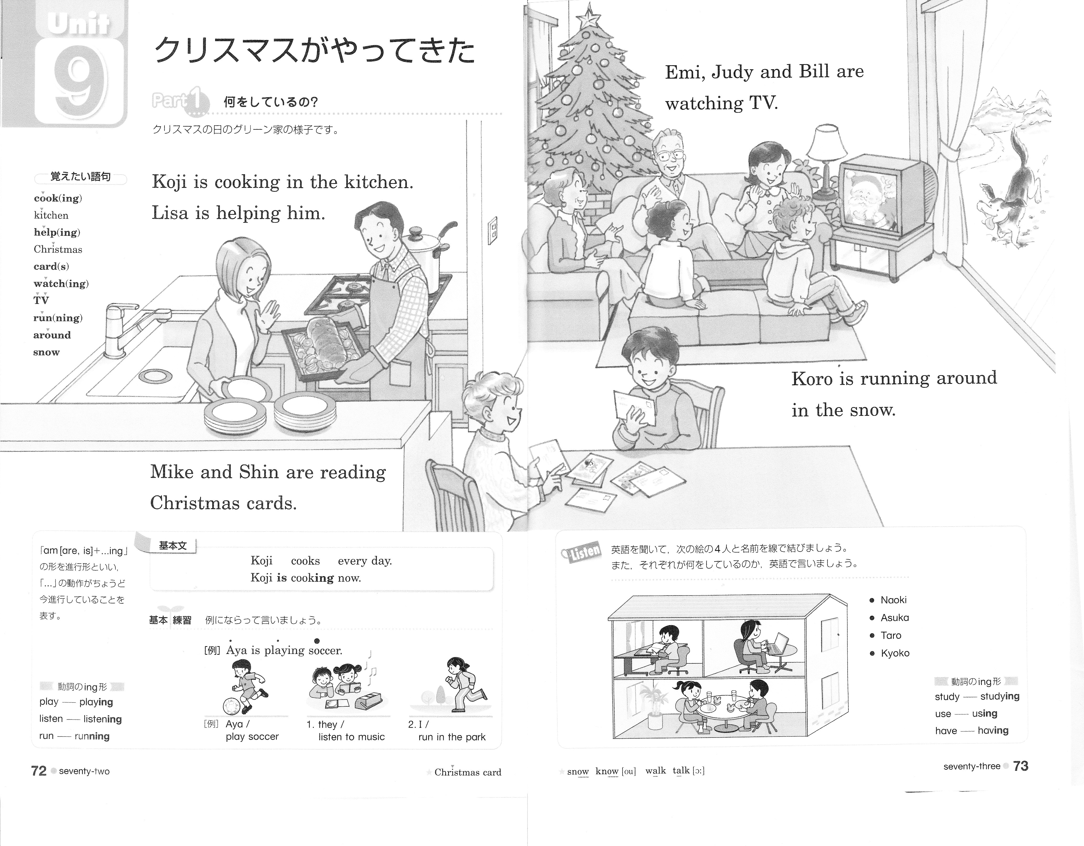

I get up at seven every morning.

シベリヤの看守と泣いて別れたなんて､きっといい人だったんだよね､お父さん。

やねよりたかいこいのぼり
おおきいまごいはおとうさん
ちいさいひごいはこどもたち
おもしろそうにおよいでる
作詞／近藤宮子 作曲／不詳
近江誠の英語コミュニケーション教育講座③－２
基礎編： コミュニケーション的精読
－語り手と空間をどう考えるか？ ―

こいのぼり

やねより高いこいのぼり
おおきいまごいはおとうさん
ちいさいひごいはこどもたち
おもしろそうにおよいでる

作詞／近藤宮子 作曲 不詳

鯉のぼり

甍（いらか）の波と雲の波
重なる波の中空を
橘香る 朝風に
高く泳ぐやこいのぼり
作詞・不明、作曲 弘田龍太郎

近江誠の英語コミュニケーション教育講座③－4
基礎編： コミュニケーション的精読
-スラッシュリーディングは言語ラング観偏重のオリ： 意味を与えるのは語り手である―

テクストからサブテクスト（せりふした）を探ること、
語り手のホンネ、下心

1234567891011１２１３１４１５１６１７１８１９２０２１２２２３２４２５２６２７２８２９３０３１．

Martini, Gin Fizz, Gimlet, Singapore Sling, Paradise, Gin Tonic, Around the World, White Lady, Moscow Mule, Balalaika, Salty Dog, Bloody Mary, Screw Driver, Kami-Kaze, Daiquiri, City Orange, Blue Hawaii.

Never, Iago. Like to the Pontic Sea whose icy current and compulsive course never feels retiring ebb but keeps due on to the Propontic and Hellspont, even so, my bloody thoughts shall ne’er look back, ne’er ebb to humble love, till that capable and wide revenge swallow them up. Now, by yond marble heaven in the due reverence of a sacred vow, I here engage my words. （Othello）

近江誠の英語コミュニケーション教育講座③－5
基礎編： コミュニケーション的精読
-目的と音声ー

An ambitious student of the natural sciences, Frankenstein, in seeking to imitate God creates in his laboratory a living creature having the form of a man but lacking a soul. It is therefore a monster.

… So it’s come at last! At last it’s come! The day I knew would come at last has come at last! My sonnyboy doesn’t need me anymore. Well, what are you waiting for? Get rid of me! （She indicates the garbage can.）Put me out with the garbage! Just throw me out with the used grapefruits and the empty cans from the Bumble-Bee salmon. Never mind putting a lid on. Leave it open so a hundred thousand pussycats can walk all over a Mother. And by the way, sweetheart darling, I got some good news for you. I got the report from the hospital. It’s absolutely definite. I got a condition. Never mind what kind of condition, a condition. And the one thing doctors can’t cure is a condition. I don’t want you to worry, though. Fancy funerals are for rich people. I don’t want you to spend a cent. Just wait ‘til Mother’s Day, wrap in a flag, and dump me in the river. (Then rising from the garbage can) Well, I feel better now. Everything is as it should be. A mother is lying on top of a Sanitation truck bound for the City Dump, and a son is running around in saloons with a Mexicali Rose who came over for the fruit picking season and stayed to ruin an American woman’s life!

-- Bye Bye Birdie by Michael Stewart,

近江誠の英語コミュニケーション教育講座③－6
基礎編 コミュニケーション的精読
―四つの目線： テキストに内在する３つと外在する１つ

赤城山の別れ／The Grateful Crane

忠治: 赤城の山も今宵限り。生まれ育った国定村や縄張りを捨て、国を捨て、かわいい子分のテメーたちとも別れ別れになる首途だ…ああ、雁が泣いて南の島へ飛んでいかぁ
子分：親方これからどちらへ行きなさるんで
忠治: 足の向くまま、気の向くままに、あてもはてしもねー旅に立つのだ。役者する身と空飛ぶ鳥はどこのいずくで果てるやら…だ
加賀の国の住人、小松五郎義兼が鍛えた業物、万年溜の雪水に浄めて、俺には生涯テメーという強い味方があったのだ。

１． 台本を見る目線
２． 観客(アクションの外にいる存在)を見る目線（直接に観客に訴えたいメッセージ）
３． 登場人物同士を見合う目線。 オンフォーカスとオフ・フォーカスとがある
４． 情景を見ている／あるいは心象を思い浮かべる目線

ヴォーカル・ヴァライエティ ーテキストに内在するものとして
一つのスピーチの中で異なる者が存在すること（１）．高低 （２）．強弱 （３）．遅速 （４）．間（ま）

機を織っているはずの妻が鶴であることを驚いたよひょうに気が付いたつうはー

…noticing the young man looking in surprise, the crane
said, “You have broken our promise, even though I
urged you not to look inside. I am the crane you once
rescued from the trap.
“You are that crane?”
“I came to you in the form of a human being because
I wanted to repay you for your kindness, but now that
you know my true nature, I cannot stay here with you.”
With these words, she turned and walked out of
the house. Yohyo rushed out the house and cried,
“ I ‘ve betrayed your trust. I do apologize. Please forgive
me. Tsu, stay by me.”
With a mighty flap of her wings, she took off into
the sky, circled once again, gave a single cry as if to say
“goodbye,” and flew off, leaving behind only the cloth
that it had just finished.
One could only hear Yohyo’s voice echoing in the
evening sky “Tsu!!”

近江誠の英語コミュニケーション教育講座④
中学１ New Horizon から

Ｉ Get Up at Six Every Morning

I get up at seven every morning.
I eat breakfast at seven twenty.
I come to school at eight fifteen.
I eat lunch at twelve thirty
I play tennis after school.
I go home at five twenty.
I eat dinner at seven.
I go to bed about ten thirty.

--The Old Version of New Horizon
Vol. I , Tokyo Shoseki

近江誠の英語コミュニケーション教育講座⑤
October the Best Month (劇的モノローグ)を使って

By Art Buckwald

…October is absolutely the best month for poor people. It’s just before election time, and all the politicians need us. Everyone promises that if he is elected, he’s going to do something for the poor. Of course, they don’t, but it gives you a warm feeling to hear everyone talking about you. Do you know that I’ve shaken hands with three congressional candidates, had my picture taken with an incumbent mayor, been interviewed on television with a guy running for governor and they told me that if I sit here all day, I might wind up in a TV commercial for a senator up for reelection?
I’ll be political campaign. A lot of people resent politicians coming into the neighborhood just before election time with their campaign managers and busloads of press. But I don’t feel that way.
I figure we’re a very important part of the democratic process. If it weren’t for poor people, the rest of the country wouldn’t know how well off they were. No matter how bad things get, the politicians can always point to us and say that the majority of the people in this country really have never had it so good. Would you like a piece of stale roll?
The only thing that disturbs me is that there are a lot of poor people now, and we’re not as much a novelty as were in previous elections. They also have us broken down in categories. Before if you were poor—you were just poor. Now you’re competing with people who are “economically disadvantaged,” “culturally deprived,” “senior citizens,” and “oppressed minorities.”
Just yesterday a guy running for police chief came in the neighborhood and I was about to shake hands with him for a TV station, when his press representative pushed me aside and said they wanted the candidate to be filmed shaking hands with a black. Now I have nothing against blacks, but I don’t think they should get priority when it comes to having their pictures taken with a guy running for chief of police. That’s what we call poverty discrimination.
Oh—oh. Here comes the senator. Well, I’ve got to get to work. What? How do I know he’ll stop here? He’ll stop here all right. It’s in front of a supermarket. All the candidates are doing supermarkets this year. There! What? No, I won’t shake hands with him, not until the TV guys are set up. Most people don’t have enough sense to wait until the press get out of their bus. Okay, they’re ready now. (walking up to Senator) Senator, what are you going to do about us poor people?(to the pals ) Don’t forget to watch the six o’clock news.
近江誠の英語コミュニケーション教育講座⑥
Tomorrow Never comes
最後だとわかっていたなら
―原詩であるNorma Cornet Marekの仮定法過去を教育目的のために仮定法過去完了で呈示した

If I had known it would be the last time that I’d see you fall asleep, I would’ve tucked you in more tightly, and prayed the Lord your soul to keep.
If I had known it would be the last time that I’d see you walk out the door, I would’ve given you a hug and a kiss, and called you back for just one more.
If I had known it would be the last time that I'd hear your voice lifted up in praise, I would've taped each word and action, and played them back throughout my days.
If I had known it would be the last time, I would’ve spared an extra minute or two “I love you,

So just in case tomorrow never comes, and today is all I get, I’d like to say how much I love you, and I hope we never will forget tomorrow is not promised to anyone, young or old alike., and today may be the last chance you get to hold your loved one tight.
So if you’re waiting for tomorrow, why not do it today? For if tomorrow never comes, you’ll surely regret the day that you didn’t take that extra time for a smile, a hug, or a kiss, and you were too busy to grant someone what turned out to be their one last wish.
So hold your loved ones close today and whisper in their ear that you love them very much, and you’ll always hold them dear. Take time to say, “I’m sorry,”and “please forgive me, …”Thank you” or “It’s okay,” and if tomorrow never comes, you’ll have no regrets about today.

近江誠の英語コミュニケーション教育講座⑦

The Great Dictator's Speech

By Charles Chaplin

I’ｍ sorry, but I don’t want to be an emperor. Thaｔ’s not my business. I don’t want to rule or conquer anyone. I should like to help everyone - if possible - Jew, Gentile - black man - white. We all want to help one another. Human beings are like that. We want to live by each other’s happiness - not by each other’s misery. We don’t want to hate and despise one another. In this world there is room for everyone. And the good earth is rich and can provide for everyone. The way of life can be free and beautiful, but we have lost the way.
Greed has poisoned men’s souls, has barricaded the world with hate, has goose-stepped us into misery and bloodshed. We have developed speed, but we have shut ourselves in. Machinery that gives abundance has left us in want. Our knowledge has made us cynical. Our cleverness, hard and unkind. We think too much and feel too little. More than machinery we need humanity. More than cleverness we need kindness and gentleness. Without these qualities, life will be violent and all will be lost....
The aeroplane and the radio have brought us closer together. The very nature of these inventions cries out for the goodness in men - cries out for universal brotherhood - for the unity of us all. Even now my voice is reaching millions throughout the world - millions of despairing men, women, and little children - victims of a system that makes men torture and imprison innocent people.
To those who can hear me, I say - do not despair. The misery that is now upon us is but the passing of greed - the bitterness of men who fear the way of human progress. The hate of men will pass, and dictators die, and the power they took from the people will return to the people. And so long as men die, liberty will never perish. .....
Soldiers! Don’t give yourselves to brutes - men who despise you - enslave you - who regiment your lives - tell you what to do - what to think and what to feel! Who drill you - diet you - treat you like cattle, use you as cannon fodder. Don’t give yourselves to these unnatural men - machine men with machine minds and machine hearts! You are not machines! You are not cattle! You are men! You have the love of humanity in your hearts! You don’t hate! Only the unloved hate - the unloved and the unnatural! Soldiers! Don’t fight for slavery! Fight for liberty!
In the 17th Chapter of St Luke it is written: the Kingdom of God is within man - not one man nor a group of men, but in all men! In you! You, the people have the power - the power to create machines. The power to create happiness! You, the people, have the power to make this life free and beautiful, to make this life a wonderful adventure.
Then - in the name of democracy - let us use that power - let us all unite. Let us fight for a new world - a decent world that will give men a chance to work - that will give youth a future and old age a security. By the promise of these things, brutes have risen to power. But they lie! They do not fulfil that promise. They never will! Dictators free themselves but they enslave the people! Now let us fight to fulfil that promise! Let us fight to free the world - to do away with national barriers - to do away with greed, with hate and intolerance. Let us fight for a world of reason, a world where science and progress will lead to all men’s happiness. Soldiers! in the name of democracy, let us all unite!
Hannah, can you hear e. Wherever you are, look up, Hannah! The clouds are lifting! The sun is breaking through! We are coming out of the darkness into the light,. We are coming out into a new world.—a kindlier world where men will rise above their hate, their greed and brutality
Look up, Hannah! The soul of man has given wings and at last he is beginning to fly. He is flying into the rainbow—into the light of hope—into future, that glorious future that belongs to you, to me and to all of us. Look up, Hannah! Look up.

近江誠の英語コミュニケーション教育講座⑧
個人商店主スピーチ（弘兼憲史『課長島耕作』原作）
日本語訳：近江誠、William Kumai

Now what worries? No problem. Well, those big outfits might be cheaper compared to Mom and Pop operations like ours. They’ve got the whole works I admit, but we’ve got something they haven’t. You know what that is? It’s heart. We take the time to talk with the customers. Hell, in their business there is no such thing as communication whatsoever. They have know-nothing salesclerks who just stand around staring at their customers. Even if the customers need help, do you think they care? Now, let me ask you this. This country is getting richer, but don’t you think we need all the more heart-to-heart communication? What is the world coming to when we can’t even say hello to people we meet on the streets?
Say, we’re getting some noodles. Wanna join us? Come on, don’t be a stranger, Mr. Shima. They got great tempura noodles at hangettsuan in front of the station.

近江誠の英語コミュニケーション教育講座⑨

姫川亜弓スピーチ
美内みすず作『ガラスの仮面』34巻
日本語訳：近江誠、William Kumai

Momma! I’m not a puppet! I’ll not stand for smiling just because someone pulls my strings. I’m a human being. I’ve got my own will. You’ve always treated me like a puppet, hidden behind the big names of you and Poppa. No one has ever looked at me as my own person, an independent woman. .. I really do envy Maya Kitajima! Whatever she does people recognize her with her own two hands. Every door she opens she becomes more famous and prettier. Momma, Momma, you’ve known all along that Maya’s a genius, haven’t you?
What she does is so natural…like she’s breathing or something, but I’ve had to toil and sweat for years. Just a little opportunity, and she turns into any role she wants. Fragile, delicate glass masks… The one wearing the glass mask is me, not Maya! Momma, I want to beat her to it…I’ve got to get the lead in the “The Scarlet Angel.” I’ll never forgive myself if I don’t. Only when my own hard work overcomes her gifted talent can I hold my head high and live my own life. The “Scarlet Angel” is me, and no one else. I’ll defeat Maya Kitajima! I’ll do anything! Maya Kitajima! My own rival!

近江誠の英語コミュニケーション教育講座⑩

"I Have a Dream" Speech
Martin Luther King Jr.
August 28, 1963
…I have a dream that one day this nation will rise up and live out the true meaning of its creed: "We hold these truths to be self-evident, that all men are created equal."
I have a dream that one day on the red hills of Georgia, the sons of former slaves and the sons of former slave owners will be able to sit down together at the table of brotherhood.
I have a dream that one day even the state of Mississippi, a state sweltering with the heat of injustice, sweltering with the heat of oppression, will be transformed into an oasis of freedom and justice.
I have a dream that my four little children will one day live in a nation where they will not be judged by the color of their skin but by the content of their character.
I have a dream today!
I have a dream that one day, down in Alabama, with its vicious racists, with its governor having his lips dripping with the words of "interposition" and "nullification" -- one day right there in Alabama little black boys and black girls will be able to join hands with little white boys and white girls as sisters and brothers.
I have a dream today!
I have a dream that one day every valley shall be exalted, and every hill and mountain shall be made low, the rough places will be made plain, and the crooked places will be made straight, and the glory of the Lord shall be revealed and all flesh shall see it together.
This is our hope, and this is the faith that I go back to the South with.
With this faith, we will be able to hew out of the mountain of despair a stone of hope. With this faith, we will be able to transform the jangling discords of our nation into a beautiful symphony of brotherhood. With this faith, we will be able to work together, to pray together, to struggle together, to go to jail together, to stand up for freedom together, knowing that we will be free one day.
And this will be the day -- this will be the day when all of God's children will be able to sing with new meaning:
"My country 'tis of thee, sweet land of liberty, of thee I sing.
From every mountainside, let freedom ring!"
And if America is to be a great nation, this must become true.
And so let freedom ring from the prodigious hilltops of New Hampshire.
Let freedom ring from the mighty mountains of New York.
Let freedom ring from the heightening Alleghenies of Pennsylvania.
Let freedom ring from the snow-capped Rockies of Colorado.
Let freedom ring from the curvaceous slopes of California.
But not only that:
Let freedom ring from Stone Mountain of Georgia.
Let freedom ring from Lookout Mountain of Tennessee.
Let freedom ring from every hill and molehill of Mississippi.
From every mountainside, let freedom ring.
And when this happens, when we allow freedom ring, when we let it ring from every village and every hamlet, from every state and every city, we will be able to speed up that day when all of God's children, black men and white men, Jews and Gentiles, Protestants and Catholics, will be able to join hands and sing in the words of the old Negro spiritual:
"Free at last! Free at last!
Thank God Almighty, we are free at last!"

Copyrighted by Dr. Martin Luther King, Jr. 1963. Authorized by The King Center, Atlanta, GA.

